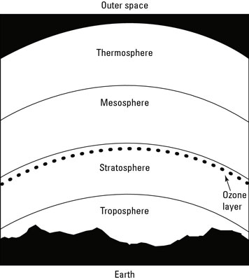

Label the diagram to indicate what happens to the temperatures in each layer of the atmosphere as the altitude increases.

1) Why do the temperatures increase with altitude in two of the layers?

2) What is the average temperature of the thermosphere? If you went there, would you notice the temperature? Why or why not?

