Ch 6 Section 3, 4, and 5 Notes

ATP Powers cellular work by coupling exergonic reactions to endergonic reactions
- A key feature in the way cells manage their energy resources is to do cell work is energy coupling, the use of an exergonic process to drive an endergonic one.
- The primary source of energy for cells in energy coupling is ATP (adenosine triphosphate). ATP is made up of the nitrogenous base adenine, bonded to a ribose sugar, and a chain of three phosphate groups. When a phosphate group is hydrolyzed, energy is released in an exergonic reaction.
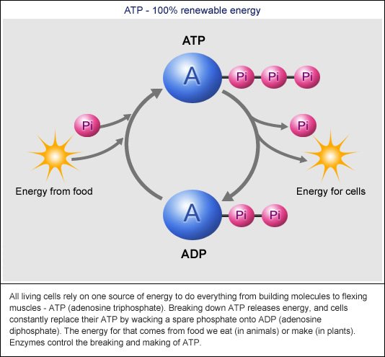
- Work in the cell is done by the release of a phosphate group from ATP. The exergonic release of the phosphate group is used to do the endergonic work of the cell. When ATP transfers one phosphate group through hydrolysis, it becomes ADP (adenosine diphosphate)

Enzymes speed up metabolic reactions by lowering energy barriers
- catalysts are substances that can change the rate of a reaction without being altered in the process
- enzymes are macromolecules that are biological catalysts
- The activation energy of a reaction is the amount of energy it takes to start a reaction – the amount of energy it takes to break the bonds of the reactant molecules. Enzymes speed up reactions by lowering the activation energy of the reaction – but without changing the free energy change of the reaction. The reactant that the enzyme acts on is called the substrate.
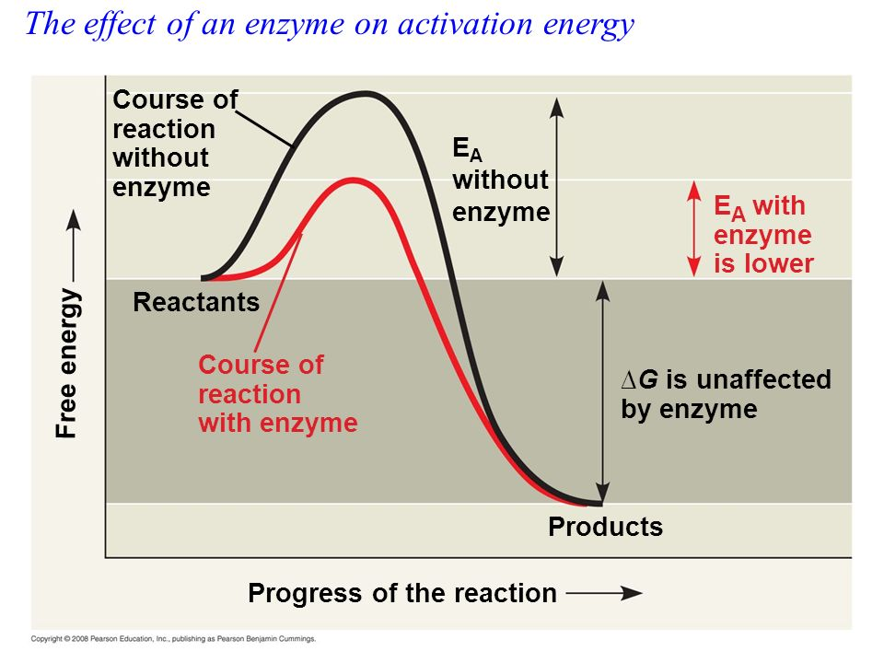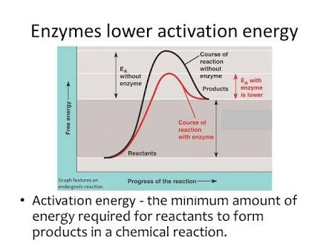

- The active site is the part of the enzyme that binds to the substrate. The enzyme and substrate form a complex called an enzyme-substrate complex that is generally held together by weak interactions. The substrate is then converted into products, and the products are released from the enzyme.
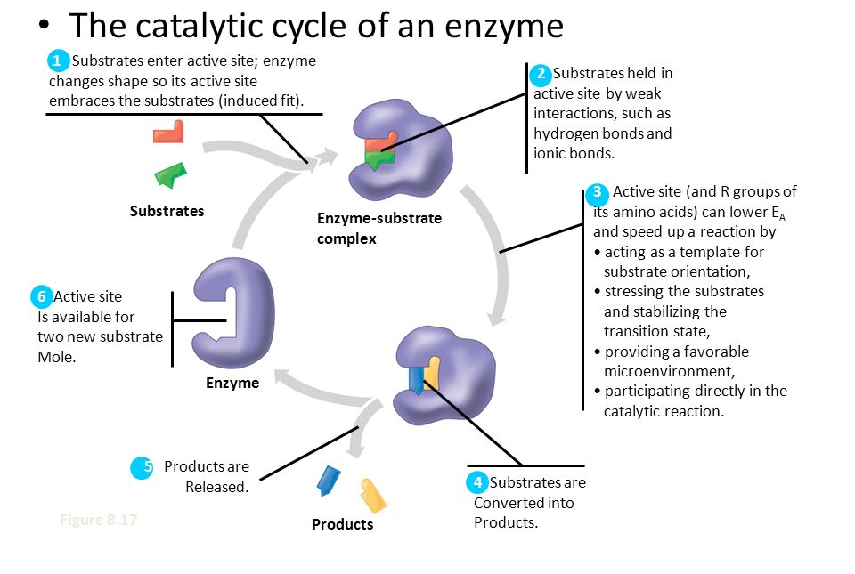
- The activity of an enzyme can be affected by several factors
  - Protein enzymes have complicated three-dimensional shapes that are dramatically affected by changes in pH and temperature. Changes in the precise shape of an enzyme usually mean the enzyme will not be as effective. Note how the rate of the reaction is altered in the graphs below when temperature and pH are not optimal
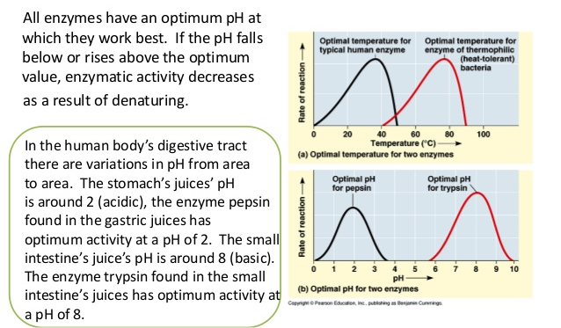
  - Many enzymes require nonprotein helpers, termed cofactors, to function properly. Cofactors include metal ions like zinc, iron, and copper and function in some crucial way to allow catalysis to occur. If the cofactor is organic, it is more properly referred to as a coenzyme. Coenzymes are organic cofactors; vitamins are examples of coenzymes.
  - Competitive inhibitors are reversible inhibitors that compete with the substrate for the active site on the enzyme. Competitive inhibitors are often chemically very similar to the normal substrate molecule and reduce the efficiency of the enzyme as it competes for the active site.
  - Noncompetitive inhibitors do not directly compete with the substrate molecule; instead, they impede enzyme activity by binding another part of the enzyme. This causes the enzyme to change its shape, rendering the active site nonfunctional.
Regulation of enzyme activity helps control metabolism
- Many enzyme regulators bind to an allosteric site on the enzyme, which is a specific binding site, but not the active site. Once bound, the shape of the enzyme is changed, and this can either stimulate or inhibit enzyme activity.
- The end product on an enzymatic pathway can switch off its pathway by binding to the allosteric site of an enzyme in the pathway. This type of allosteric inhibition is termed feedback inhibition. Feedback inhibition increases the efficiency of the pathway by turning it off when the end product accumulates in the cell.

