Mendelian Genetics

Meiosis and Sexual Life Cycles
Offspring acquire genes from parents by inheriting chromosomes
- genes are segments of DNA that code for basic units of heredity and are transmitted from one generation to the next. In animals and plants, reproductive cells that transmit genes from one generation to the next are called gametes.
- A locus (plural, loci) is the location of a gene on a chromosome.
  - In asexual reproduction a single parent is the sole parent and passes copies of all its genes to its offspring. In asexual reproduction the new offspring arise by mitosis and have virtually exact copies of the parent’s genome. An individual that reproduces asexually gives rise to a clone, a group of genetically identical individuals
  - in sexual reproduction, two individuals (parents) contribute genes to the offspring. This form of reproduction results in greater genetic variation in the offspring than asexual reproduction.
- Fertilization and meiosis alternate in sexual life cycles
  - A life cycle is the generation-to-generation sequence of stages in the reproductive history of an organism, from conception to production of its own offspring.
  - Somatic cells are any cells in the body that are NOT gametes. Each somatic cell in humans has 46 chromosomes. Liver cells and neurons are somatic cells.
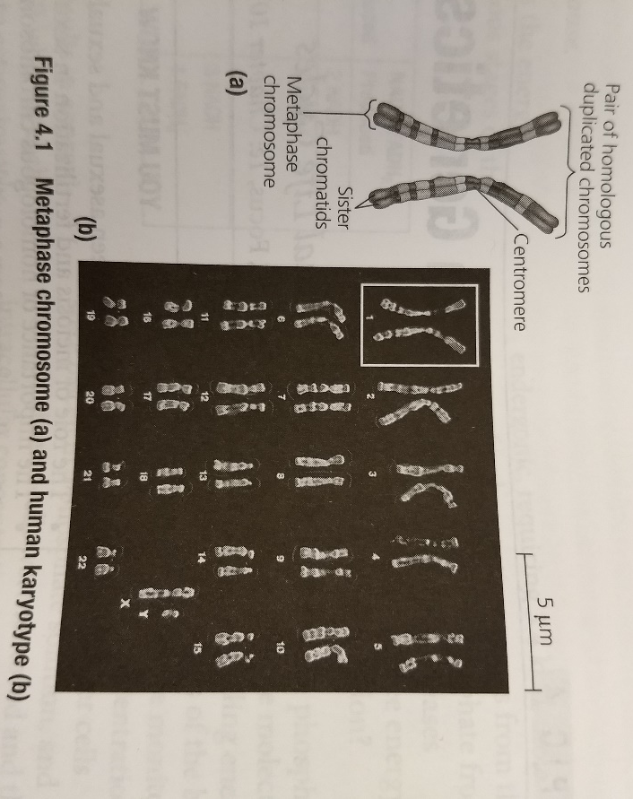
  - The karyotype of an organism refers to a picture of its complete set of chromosomes, arranged in pairs of homologous chromosomes, from the largest pair to the smallest pair.
  - In homologous chromosomes both chromosomes of each pair carry genes that control the same inherited characteristics. If a gene for eye color is found at a specific locus on one chromosome, its homologs will have the same gene at the same locus.
    - Homologous chromosomes are similar in length and centromere position, and have the same starting pattern
    - One homologous chromosome from each pair is inherited from each parent; in other words, half of the set of 46 chromosomes in your somatic cells was inherited from your mother, and the other half was inherited from your father.
  - Exceptions to the rule that all chromosomes are part of a homologous pair may be found with the sex chromosomes – in humans, it is the X and Y. Human females have a homologous pair of chromosomes XX, but males have one X chromosome and one Y chromosome. Nonsex chromosomes; that is, all the chromosomes except X and Y are called autosomes.
  - What sex did the somatic cell come from that was used to make the karyotype in the figure above?
  - Gametes – meaning sperm and ova (eggs) – are haploid cells. Haploid cells contain half the number of chromosomes of somatic cells. In humans, gametes contain 22 autosomes plus a single sex chromosome (X in female, either X or Y in male), giving them a haploid number of 23. The haploid number of chromosomes is symbolized by n.
  - Meiosis and fertilization are the key events in sexually reproducing life cycles. The human life cycle is typical of a sexually reproducing animal. Note the key points in the figure as you read about the life cycle.
  - During fertilization (the combination of a sperm cell and an egg cell), one haploid gamete from the father fuses with one haploid gamete from the mother. The result is a fertilized egg called a zygote. It is diploid (has two sets of chromosomes) and may be symbolized by 2n
  - Meiosis is the type of cell division that reduces the numbers of sets of chromosomes from two to one. Fertilization restores the diploid number as the gametes are combined. Fertilization and meiosis alternate in the life cycles of sexually reproducing organisms.

